# ELECTRICAL POWER SYSTEM IN SATELLITES

## INTRODUCTION

The growth of small satellite missions (1U CubeSats and other hobbyist nanosatellites) has shown the importance of compact, efficient electrical power systems (EPS). CubeSats are a class of nanosatellites that use a standard size and form factor.  The standard CubeSat size uses a “one unit” or “1U” measuring 10x10x10 cms and is extendable to larger sizes; 1.5, 2, 3, 6, and even 12U. The EPS is one of the main composites of the satellites, which works on the power generation, storage, delivery and conditioning. Without any of those, the satellites would be out of service and may cause the failure of the whole mission.

Collecting routine information from various sub-systems and sensors is also a core function of the EPS. This involves measuring various important voltages, currents, and temperatures which are called the “Housekeeping Parameters.”

Small satellites typically operate in low-Earth orbit (LEO) with relatively low thermal and radiation environments and short mission durations, allowing them to rely on commercial-off-the-shelf (COTS) components to minimize cost and development time.

The design process starts by estimating payload power requirements, sizing the solar panels to meet average power needs (with margin for eclipse), and sizing the batteries to supply worst-case eclipse loads. Each subsystem is discussed below.

## Energy Generation

For the energy generation, Photovoltaic cells (PV cells) are employed, where the electrical parameters “voltage and current” of these cells are sensed and then sent to the control circuit or microprocessor. To maximize generation, they employ maximum-power-point tracking (MPPT). An MPPT converter (typically a switching DC–DC regulator) actively adjusts the panel operating point to match the maximum power point under varying illumination and temperature. Each solar panel input has its own MPPT channel so each panel can operate at peak power independently.Some simple CubeSat designs use *direct energy transfer* (DET) instead: a passive diode isolates each solar string, and the panel’s current simply flows directly into the battery/bus. This DET approach is less efficient (the array may not operate at its peak point) but requires minimal hardware.

Technologies applicable to small spacecraft include advanced multi-junction, flexible and organic solar cells, hydrogen fuel cells, and a variety of thermo-nuclear and atomic battery power sources. Photovoltaic cells, or solar cells, are made from thin semiconductor wafers that produce an electric current when exposed to light. The light available to a spacecraft solar array, also called solar intensity, varies as the inverse square of the distance from the sun. The projected surface area of the panels exposed to the sun also affects power generation and varies as a cosine of the angle between the panel and the sun.

While single-junction cells are cheap to manufacture, they carry a relatively low efficiency, usually around 20%. Modern spacecraft designs favour multi-junction solar cells made from multiple layers of light-absorbing materials that efficiently convert specific wavelength regions of the solar spectrum into energy, thereby using a wider spectrum of solar radiation. The theoretical efficiency limit for an infinite-junction cell is 86.6% in concentrated sunlight However, in the aerospace industry, **triple-junction cells** are commonly used due to their high efficiency-to-cost ratio compared to other cells and because this junction combination captures longer wavelength.

Typical 1U panels use two or more triple-junction GaAs cells (InGaP/GaAs/Ge) on each face. In LEO, a 1U panel can generate on the order of 2–3 W at peak illumination.

The efficiency of the solar cells can be improved further by using concentrators. The concentrator uses lenses and curved mirrors to focus and direct the solar irradiance onto the multijunction solar cell. In this way, the efficiency of the solar cell can be improved at minimal additional cost as compared to using a different solar cell chemistry.

Ultimately the size, weight, and volume of smaller satellites may be the determining factor in choosing solar cell technology, rather than solar cell efficiency. Being a life-limiting component on most spacecraft, the End-of-Life (EOL) performance at operating temperature is critical in evaluating their performance. Common factors that degrade the functionality of solar cells include radiation exposure, cover glass/adhesive darkening, contamination, and mechanical or electrical failure.

## Energy Storage

The power harvested by the PV cells is delivered both to the payloads and battery. The batteries are charged during high solar irradiance levels when the power generated by the solar arrays is higher than the loads one.

The energy stored is a backup for the eclipse when the satellite goes to the dark side of the planet “or orbit” where the PV cells get shaded or during peak loads, even when the CubeSat is subjected to the sun. The battery could be paralleled directly to the main bus or interfaced through a bidirectional converter.

Primary and secondary batteries are used for power storage and are classified according to their different electrochemistry. As primary-type batteries are not rechargeable, they are typically used for short mission durations. Silver-zinc is typically used as they are easier to handle and discharge at a higher rate, however, there are also a variety of lithium-based primary batteries that have a higher energy density, including lithium Sulfur dioxide (LiSO2), lithium carbon monofluoride (LiCFx) and lithium thionyl chloride (LiSOCl2)

Secondary-type batteries include nickel-cadmium (NiCd), nickel-hydrogen (NiH2), lithium polymer (LiPo) and lithium-ion (Li-ion), which have been used extensively in the past on small spacecraft. Lithium-based secondary batteries are commonly used in portable electronic devices because of their rechargeability, low weight, and high energy, and have become ubiquitous on spacecraft missions. They are generally connected to a primary energy source (e.g., a solar array) and can provide rechargeable power-on-demand. Each battery type is associated with certain applications that depend on performance parameters, including energy density, cycle life, and reliability

The size and technology of batteries for satellites are selected based on the capacity and power delivery requirements, temperature ranges, number of expected service cycles, and physical size and weight. Lithium-ion (Li-ion) batteries offer higher energy density, higher operating voltage, higher service cycles and reliability in general. However, Li-ion batteries suffer at low temperatures (capacity and lifetime drop sharply below ~0°C). Regardless of the battery chemistry, their capacity degrades with the count of charge/discharge cycles, the quantity of charge change in each cycle, discharge current, and temperature.

For very high-power pulses (e.g. if the payload includes radar or high-data-rate transmitters), some systems augment batteries with supercapacitors (ultracapacitors) to buffer peak loads. These hybrid solutions combine a Li-ion battery (for energy capacity) with a supercapacitor (for high power capability), improving efficiency at low temperatures and reducing battery stress.

During the selection process of the battery for a space mission, several factors need to be taken into account to have an estimate of the battery’s end-of-life (EOL). Among these factors, the number of charge and discharge cycles of the battery, especially in satellites orbiting in LEO, as their number of cycles could reach up to 16 cycles per day. The depth of discharge (DOD), which indicates the percentage of how much energy can be used from the battery is another factor. Another way is to estimate the battery’s state-of-charge (SOC), which defines what is the minimum SOC that the battery could bear without any risk of getting damaged. Other factors of paramount importance are the battery maximum charge voltage, or else known as the end-of-charge (EOC) voltage, and the minimum discharge voltage, or else known as the end-of-discharge (EOD) voltage.

Batteries carry an inherent risk of combustion from physical damage as well as thermal runaway due to overcharge. As a result, spacecraft often carry parasitic weight in the form of cooling systems and housing units.

## Energy Distribution

The collected and stored power must then be distributed to other systems throughout the satellite as needed. Power management and distribution (PMAD) systems control the flow of power to spacecraft subsystems and instruments and are often custom designed by for specific spacecraft power requirements. The EPS also protects the electronics and batteries from off-nominal current and voltage conditions.

A power distribution system consists of cabling, fault protection, and switching gear to turn power on and off to the spacecraft loads. Power distribution designs for various power systems depend on source characteristics, load requirements and subsystem functions. In selecting a type of power distribution, one focuses on keeping power losses and mass at a minimum while attending to survivability, cost, reliability, and power quality.

Most smallsat EPS use a main regulated bus (often ~8.2 V from a 2-series Li-ion pack) and then derive lower voltages (e.g. 5 V, 3.3 V) for digital electronics. Power distribution is handled by a PMAD unit that includes regulators, switches, and protections. In practice, the EPS continuously monitors battery voltage and solar panel conditions (via telemetry), and controls switching circuits (electronic or mechanical) to power subsystems on or off. Most CubeSat EPS provide overcurrent and overvoltage protection: for example, diodes isolate parallel panels, and fuses or poly-switches can protect against short circuits. Some EPS boards are equipped with built-in load switches that are commanded by the on-board computer (OBC) or a local microcontroller.

EPS designs vary between **centralized** and **distributed** topologies. A centralized bus is simple and each subsystem is connected to a single circuit board. This approach provides volume efficiency, and inexpensive component cost. However, a centralized EPS is rarely reused, as most of the subsystems need to be altered based on new mission requirements.  Alternatively, a distributed approach dedicates converters or regulators for each subsystem or “power rail,” which can improve efficiency and modularity.

The main bus is connected to an overvoltage protection device. Moreover, each load is linked to a protection circuit which shuts down the corresponding load if it draws a current that is at a higher level than the maximum specified one for that load. This may occur if the load suffers from an internal latch up. The high levels of radiation in space can cause “single event latch-up” in the semiconductor devices on the satellite. The CubeSat employs also a kill switch, or else known as the emergency stop. This works on turning off the satellite in case of an emergency. The difference between the kill switch and the normal shutdown is that the former is quicker, simpler, and works in a non-orderly fashion even if this damages some equipment.

## Selecting an Electrical Power System for a mission

When assessing whether a particular EPS is the best fit for the mission, the typical space hardware criteria of Size, Weight, and Power (SWaP) are important.

* **Size** – power equipment can take up lots of spacecraft volume, relative to the overall size, and the power that can be generated by solar panels is a function of their surface area, meaning size is a very important characteristic.
* **Weight** – similarly, EPS hardware can account for a significant amount of the mass budget. Batteries are relatively heavy compared to other subsystems. So, weight is a key limiting factor.
* **Power** – selecting the most suitable EPS will require a clear indication of the satellite’s overall power budget range, and the operational power requirements of the EPS itself will also need to be factored in.

The satellite itself may need multiple voltage levels for different sensors and subsystems. Managing these levels is another function of the system; the satellite EPS houses a power conditioning unit which is able to deliver the required amount of electrical power at several voltages. It also plays an important role in monitoring spacecraft status.

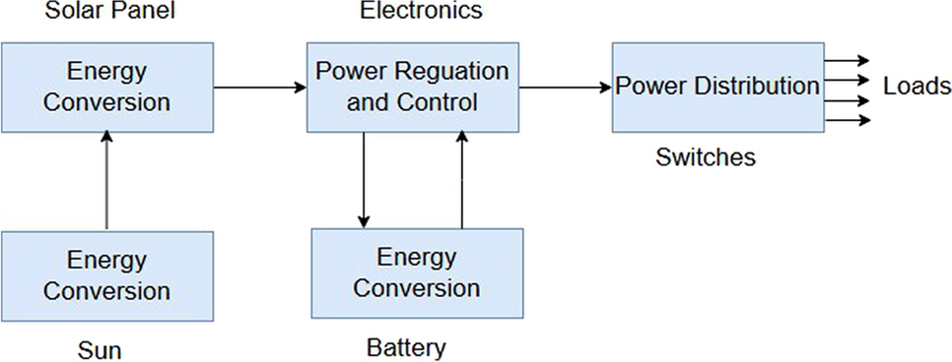

*Figure 1: Essential elements of CubeSat’s EPS. From Elsheikh, M. H. (2025). Power electronic solutions for small spacecraft: A CubeSat perspective. Discover Space.* [*https://doi.org/10.1007/s43937-025-00069-5*](https://doi.org/10.1007/s43937-025-00069-5)

## EPS Design

## Batteries

The solar cells, batteries, and converters (current/voltage adjusting circuits) are the backbone of the satellite’s EPS. Several types of batteries are used for satellite missions, such as Lithium-Ion (Li-Ion), Nickel Cadmium (NiCd), and Nickel Metal Hybrid (Ni MH). Each type has its unique specifications, but the preferred type, for CubeSats missions, is the **Li-Ion** because it meets the constraints of mass and volume.

The required energy of the satellite’s subsystems $E_{tot}$  can be written as follows:

$E_{tot}= \frac{E}{η}$ Equation 1

where E represents the energy obtained from the solar cells, and η is the conversion stage efficiency. Therefore, we can determine the number of batteries to provide the needed amount of energy for the CubeSat’s subsystems.

The solar cells’ harvested energy is given as:

$E_{sun}= \int_{0}^{T_{sunlight}}{P_{in}\left(t\right).dt}$ Equation 2

where $T_{sunlight}$  is the interval in which the CubeSat receives the solar irradiance, and $P_{in}\left(t\right)$ is the instantaneous received power. Thus, the batteries’ energy is the difference between the total subsystems’ requirements and the energy generated by the solar cells.

The batteries’ energy can be expressed as:

$E_{batt}^{r}≥ η. (E_{sun}- \frac{T_{sunlight}}{T_{orbit}} E_{tot})$ Equation 3

Where $E_{batt}^{r}$ is the energy required from satellite’s batteries and $T_{orbit}$ is the rotation period of the CubeSat around the Earth.

As a result, one nominal battery energy can be described as follows:

$E_{batt}= \frac{U_{max }+ U_{min}}{2}.C$ Equation 4

Where the Li-Ion battery voltage limits are $U_{max}$ and $U_{min}$, whereas C represents the battery capacity in Ah.

Hence, the needed number of batteries would be:

$η= \frac{E_{batt}^{r}}{E_{batt}}$ Equation 5

The Panasonic 18650 Li-ion cells, are well-suited to meet the energy storage requirements of the 1U CubeSat platform. These cells offer high energy density (~3.4 Ah per cell), low self-discharge, and a proven flight heritage in space applications.

## Converters

The regulation of voltages/currents is achieved using synchronous boost and buck converters. Hence, the number and type of converters are defined based on the CubeSat subsystems’ voltage/current requirements.

The converter design process begins by specifying the performance requirements, including the desired output efficiency, the operating frequency range, acceptable voltage and current ripples, and defined voltage and current safety margins. These input parameters are the foundation for determining the converter’s operating characteristics. Once they are established, the next step involves calculating the appropriate duty cycle range, which is derived based on the given design constraints. With the duty cycle range known, one needs to compute the maximum permissible values for inductance (L) and capacitance (C), ensuring that they align with the specified ripple and margin conditions. After that, the designed converter efficiency is calculated based on the obtained parameters.

## Solar Cells

CubeSats use body-mounted solar panels with space-grade cells. Typical 1U panels use two or more **triple-junction cells** (InGaP/GaAs/Ge) on each face. These cells have high efficiency (~28–32%) and radiation tolerance. Panels include cover glass, bypass diodes and often built-in sun sensors or ADC for attitude sensing.

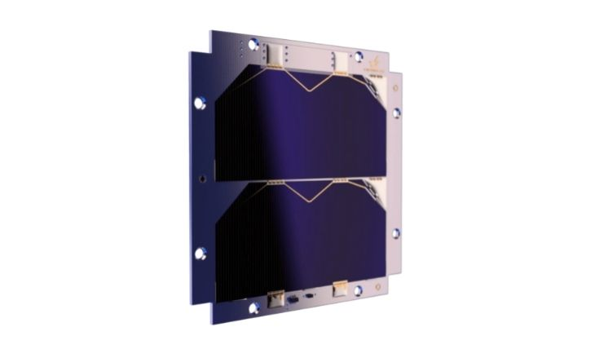

Figure 2: Example of a 1U solar panel